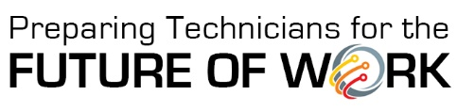
Telling Your Story:
Developing Cross-Disciplinary Scenarios
Scenario Parameters
- Provides a realistic story that situates the problem/lesson in the advanced technology workplace (e.g. advanced manufacturing, ag, biotech, autonomous, energy, environmental, engineering, geospatial, IT, cybersecurity, micro/nanotech, etc.)

- Requires a cross-disciplinary approach integrating at least one of the Cross-Disciplinary STEM Core skill sets

- Asks students to examine a complex situation and think critically to address an issue or resolve a problem.
Ex: Asking Advanced Manufacturing students to address an automation problem is not a stretch; asking Environmental Technologies students to address automation/robotics is a bigger stretch.

