[For use in Action 4.2 ]
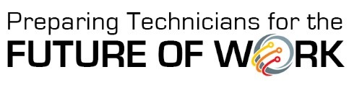
Real-World Scenario Interview Template
Use this template to take notes while interviewing an employer to develop a real-world scenario.

Company Information
- Company Name:
- Name and Position of Employee:
- Ask: May we include your company name and logo when sharing your scenario in
___________________________________ courses at ____________________________ Community College?
- Yes – company name and logo can be used
- Yes – company name can be shared
- No – neither company name nor logo can be shared

Cross-Disciplinary Skill Set to be Emphasized
Check one of the three broad skill areas then select the cross-disciplinary STEM skill set that will be the focus of the scenario to be developed. Refer to the Skill Sets Glossary if needed.
- Data Knowledge & Analysis
  - Skill set _______________________ (e.g., data modeling, data storage)
- Advanced Digital Literacy
  - Skill set _______________________ (e.g., artificial intelligence, edge computing)
- Business Knowledge & Processes
  - Skill set _______________________ (e.g., communication, market trends)

Scenario-Building Questions
- What is the technician job title that will be the focus of the scenario?

- What are the typical duties of the technician?

- Describe a problem the technician might encounter with a focus on _________ (cross-disciplinary skill set indicated above)?

- How might this problem impact the company?

- What are the steps the technician would follow to address the problem?

Step 1:

Step 2:
Step 3:

Step 4:

(add more, if needed)

- What outcome would demonstrate the problem has been resolved?

