[For use in Action 4.2 ]
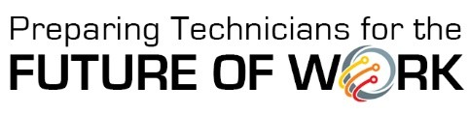
Real-World Scenario Planning Checklist
This tool can be used to organize and track progress on each real-world scenario being developed in partnership with regional employers.
Remember that scenarios:
- Contain fact-based stories with input from regional employers
- Provide workplace context for the Cross-Disciplinary STEM Core skill sets
- Prepare students to examine a complex situation
- Illustrate the need for using an integrated, cross-disciplinary instructional approach
Instructional Leader or Faculty Member
Name:
Department:
Cross-Disciplinary STEM Core Skill Area
- Data Knowledge and Analysis
- Advanced Digital Literacy
- Business Knowledge and Processes
Skill Set (refer to Skill Sets Glossary, if needed)
_________________________________
Employer Partner
Company Name:
Contact Name:
Contact Phone Number/Email:

Completion Checklist
- Reached out to employer(s) to describe the purpose of the activity; arranged for a follow-up call
- Interviewed employer to complete Real-world Scenario Interview Template
- Drafted scenario
- Sent scenario to employer for review and comments
- Shared scenario with the Cross-Disciplinary STEM Core Implementation Team

