[For use in Action 2.2 ]  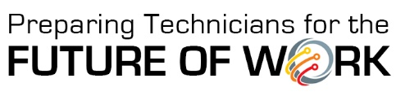 | INSERT COLLEGE LOGO

Regional Employer Convening
<DATE(S)> <TIME(S)>

Session 1
Welcome and Introductions
Impact of Technology
- Technological advancement and national/global trends
- Discussion: How has advancing technology affected your company and its workers?
Future-Proofing STEM Technicians
- The Framework for a Cross-Disciplinary STEM Core
- Skill sets in Data Knowledge & Analysis, Advanced Digital Literacy, and Business Knowledge & Practices
- The need for regional employer prioritization of the skill sets
Closing and Next Steps
Session 2
Welcome and Introductions (if needed)
Skills Prioritization Activity
Top Fifteen Skill Sets Revealed
- In what situations do technicians use these skills at your company?
- Which skill sets should be priorities for technician education in the immediate future?
Closing and Next Steps

